Monday | Tuesday | Wednesday | Thursday | Friday | Saturday | Sunday
Daily Activities (Subject to Change)  8:00-9:00 Continental Breakfast  9:00-10:00 Welcome and Coffee Chat  10:00-10:30 Artistic Corner  10:30-11:00 Let’s Get Fit Chair Exercises  11:00-12:00 Mental Stimulation or Memory Games  12:00-1:00 LUNCH  1:00-1:30 Afternoon Stretch/Walking  1:30-2:30 Game Time / Craft Special  2:30-3:00 SNACKS  3:00-5:00 Recreational Fun/ Participant’s Choice |  |  |  | 1 | 2 | 3
 |  |  |  | 11:00-12:00 Ball & Balloon Toss  1:30-2:30 Variety Fun Games  3:00-4:00 Wheel Of Fortune | 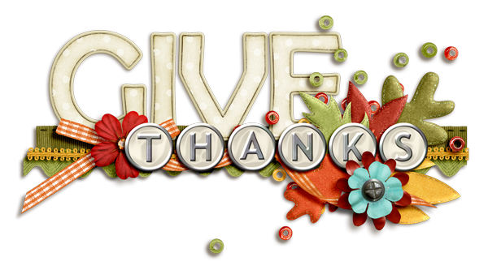
4 | 5 | 6 | 7 | 8 | 9 |  | 10
11-12: Memory Lane  1:30-2:30: Hit the Penny  3-4: Parachute Fun | 11-12: Know It All  1:30-2:30: Black Jack Surprise  3-4: Ball & Balloon Toss | 11-12: Counting Frenzy  1:30-2:30: Price Is Right  3-4: Putt Putt Golf & Game Table Blast | 11-12: Lotus Band  1:30-2:30: Pennie Pitching  3-4: Wheel Of Fortune | 11-12: Spelling “B”  1-2:30: Thanksgiving Craft Surprise  3-4: Bean Bag Bonanza | 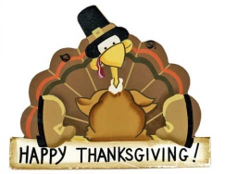 |  | Give Thanks for a Little and you will Find a Lot
11 | 12 | 13 | 14 | 15 | 16 |  | 17
11-12: Look On The Bright Side  1:30-2:30: Name That Tune  3-4: Ringer Madness | 11-12: Guidepost Inspiration  1:-2:30: String Art Supreme  3-4: Spare & Strikes | 11-12: Storytelling splendor  1:-2:30: Super Target Bingo  3-4: Blackjack | 11-12: Spelling “B”  1:30-2:30: Pennie Annie  3-4: Wheel Of Fortune | 11-12: Letters Game``  1:30-2:30: Let’s Make A Deal  3-4 Connect 4/Go Fish Puzzle | Thanksgiving is a time of togetherness & Gratitude |  | 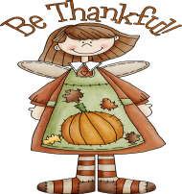
18 | 19 | 20 | 21 | 22 | 23 |  | 24
11-12: Counting Frenzy  1:30-2:30: Dicey Dimes  3-4: Ball & Balloon Toss | 10:30-12: Cooking Club Pizza Mania  1:30-2:30: Hit The Penny  3-4: Spelling “B” | 11-12: Lotus Band  1-3: Thanksgiving Craft  3-4: Ringer Madness | THANKSGIVING  DINNER | 11-12: Name That Tune  1-2:30: Pennie Annie  3-4: Blackjack | May Our Hearts Be Filled with Thanks and Giving |  | 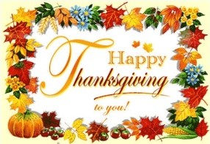
25 | 26 | 27 | 28 | 29 | 30
11-12: Positive Thinking  1:30-2:30: Uno Cards  3-4: Putt Putt Golf & Game Table Blast | 11-12: Letters Game  1:30-2:30: Wheel Of Fortune  3-4: Dicey Dimes | 11-12: Know It All  1:30-2:30: Price Is Right  3-4: Connect 4/Go Fish Puzzles | 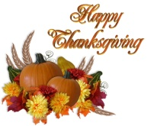 | CLOSED | 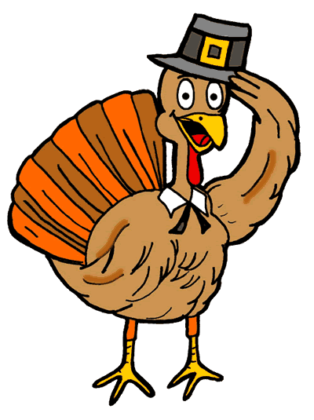 |  | 